Plot training objects with n feature scores in n dimensional space. When classifying new object compare to the k-nearest neighbors in this n feature space, can use weights, to classify new object into space

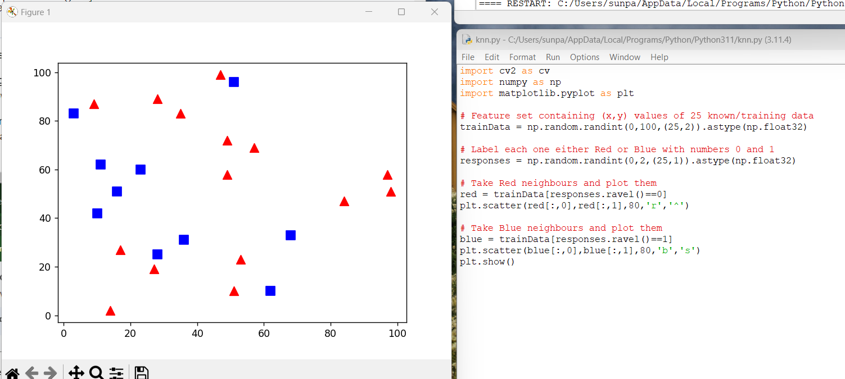

Randomized set with 2 classifications in 2 space

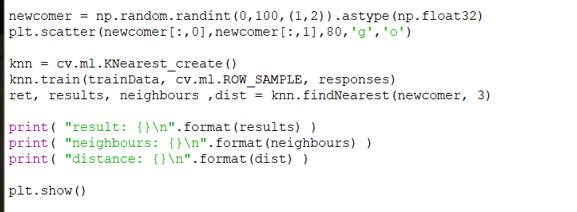

Code to create new object to be classified and colored green

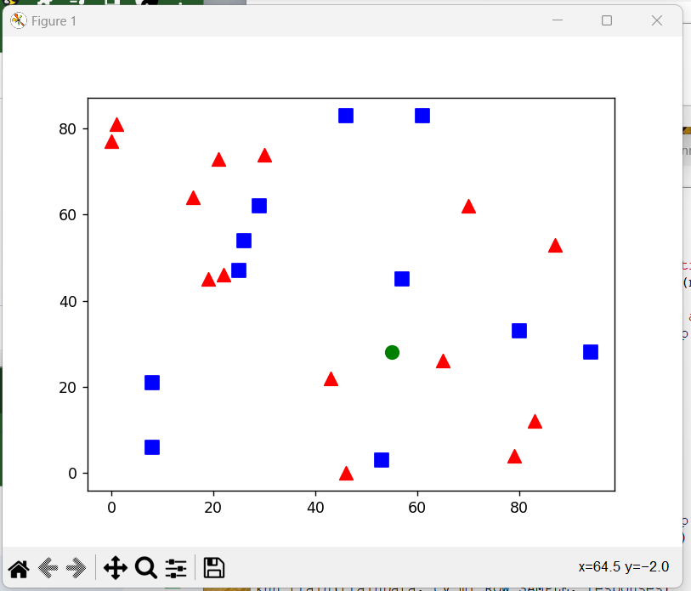

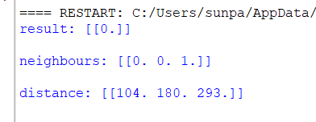

The result is a 0 , which is a triangle, because its 3 closest neighbors are two triangles vs one square